**Computer Organization Fall 2024**

**HKBU-BNU United International College**

**Lab 6: LC-3 Machine Language Programming**

# Lab Objective

To learn how to program in binary using the LC-3 machine language.

# Introduction

LC-3’s ISA has 15 instructions as shown in Figure 1.

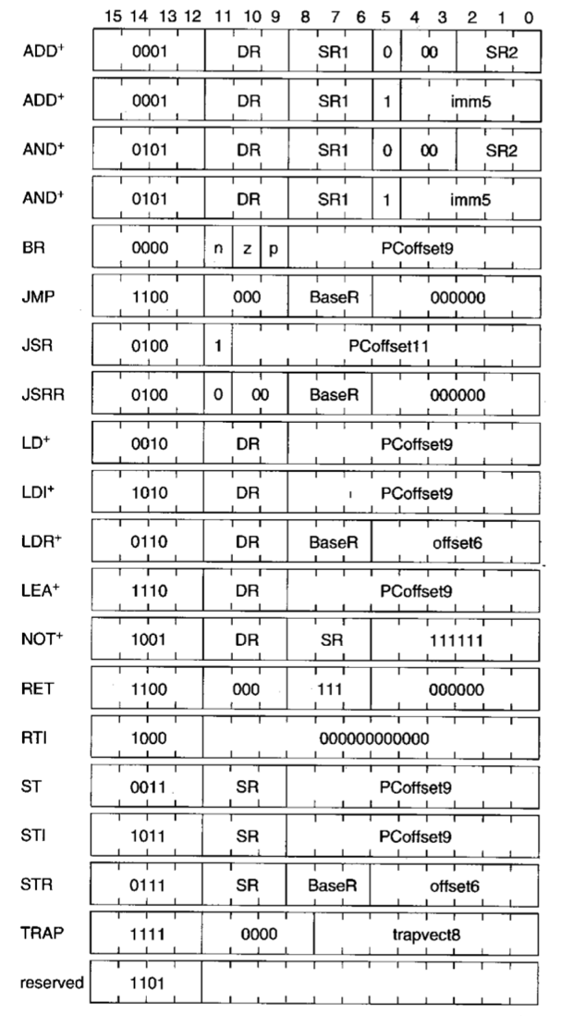

Figure 1 Formats of the entire LC-3 instruction set.

NOTE: + indicates instructions that modify condition codes

They are:

* 3 operate instructions (ADD(0001), AND(0101), NOT(1001)),
* 7 data movement instructions (LD(0010), LDI(1010), LDR(0110), LEA(1110), ST(0011), STI(1011), STR(0111) )
* and 5 control instructions (BR(0000),JMP/RET(1100),JSR/JSRR(0100), TRAP(1111), RTI(1000)).

Operate instructions process data. Data movement instructions move data between the general purpose registers and memory. Control instructions change the sequence of the instructions that are executed. The LC-3 has five opcodes that enable the change of the sequence of the control: BR(conditional branch), JMP(unconditional jump), JSR/JSRR(subroutine call), TRAP(input output system routine) and RTI(return from interrupt).

An **addressing mode(寻址模式)** is a mechanism for specifying where the operand is located. An operand can generally be found in one of the three places: in memory, in a register, or as a part of the instruction. The LC-3 supports five addressing modes: **immediate**, **register**, and three memory addressing modes: **PC-relative (PC+Offset)**, **Base+Offset** and **indirect**. Operate instructions use two addressing modes: register and immediate. Data movement instructions use all five addressing modes.

# Lab Instruction

**Step 1: Open** [**http://lc3tutor.org/**](http://lc3tutor.org/) **to use the online LC-3 simulator.**

**Step 2: Click on the “Raw” button at the bottom of the memory, an input dialog will pop up for you to input LC-3 machine code in binary or in hexadecimal.**

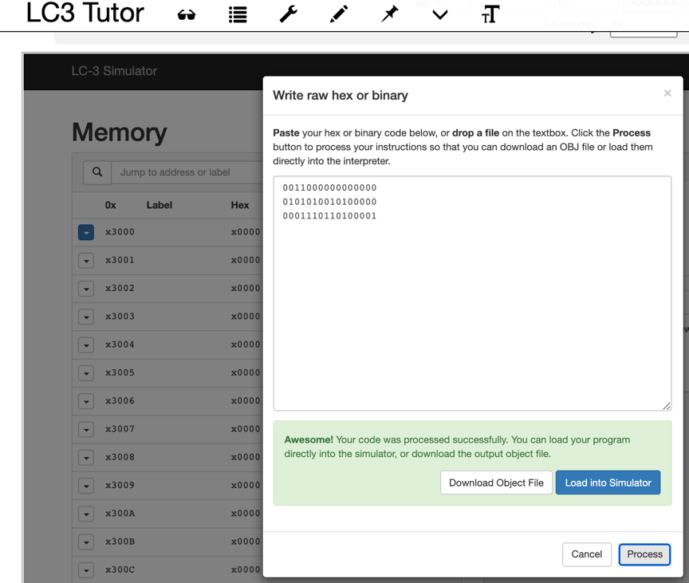

**Figure 2 Input machine code in binary to the online LC-3 simulator**

**Step 3: Input the binary code as shown in Figure 2. Click the “Process” button, if everything is ok, you will see “Awesome!** Your code was processed successfully. You can load your program directly into the simulator, or download the output object file.**”,**

**The first line is 0x3000, which tells the simulator where the second and the third lines of code is loaded in the memory.**

**Step 4: Click the “Load into Simulator” button, the second and the third line of the code will be loaded into memory location 0x3000 and 0x3001 as shown in Figure 3. Notice that PC = x3000.**

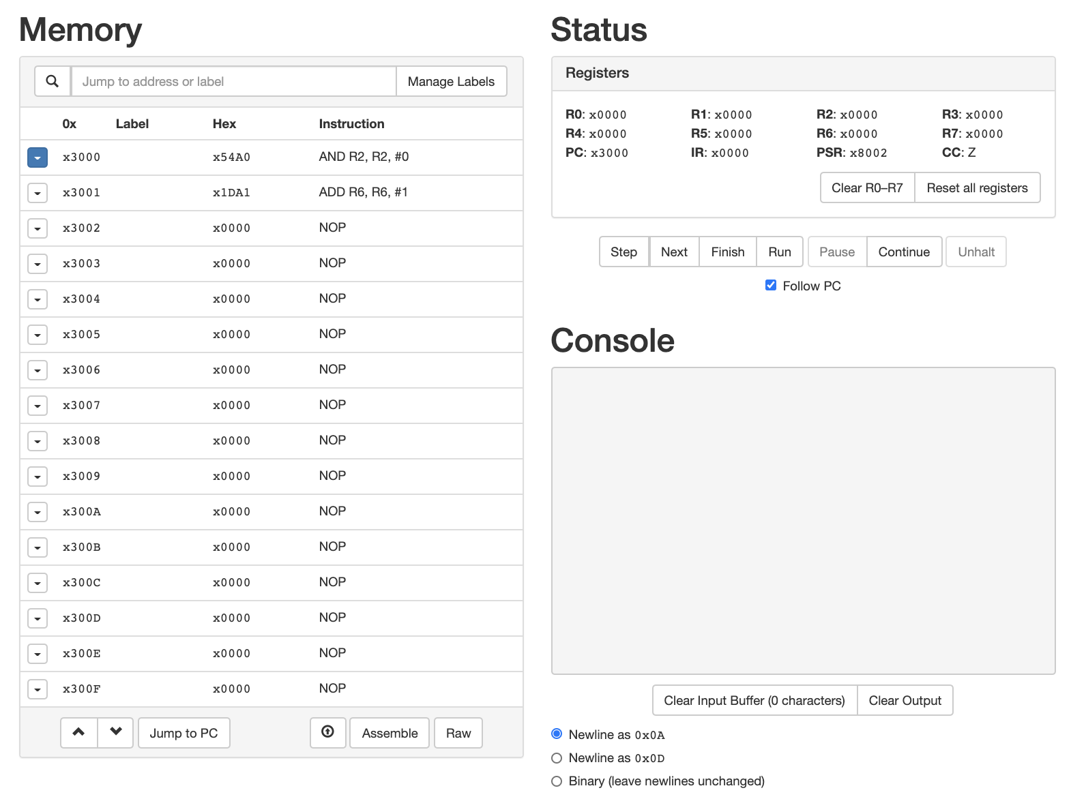

**Figure 3 Machine Code being loaded into the Memory**

**Step 5: Click the “Step” button over the Console area to execute the instruction step by step. Try to understand what the instruction does and observe carefully the change of contents of the registers.**

# Lab Exercise

1. **What does the following code? (There are 3 instructions.)**

0011000000000000

1001001001111111

0001010001100001

0001010000000010

1. Input the following code and try to understand what it does by executing it step by step. (There are 6 instructions.)

0011000000000000

1110001111111101

0001010001101110

0101010010100000

0001010010100101

0111010001001110

1010011111110111

# Analyze and explain what these instructions do one by one. You need to explain the opcode, the addressing mode and the meaning and function of these instructions.

1. Write a LC3 machine code program to print out “Hello World!”. Hint: consider to use Trap instruction PUTS.

# Submission

Upload the report file (.doc, or .pdf) into ISpace. Please name the report file with your student ID.